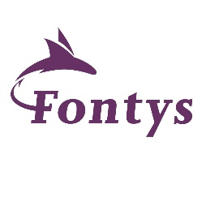
Letter of Confirmation

Re: Competence in the English Language

Date

To Whom lt May Concern

Fontys Unlverslty of Applied Sciences in Eindhoven, The Netherlands, hereby confirms that:
Student Name:

Student Number:
Education Programme of years:

Has an advanced level ( ) in reading, writing, listening, and speaking în the English language.

Therefore, we trust that the student wlll be perfectly capable of attending courses in English at University level.

Yours faithfully,

Fontys University of Applied Sclences
Fontys ICT

P.O. Box 347
5600 AH Eindhoven
The Netherlands

