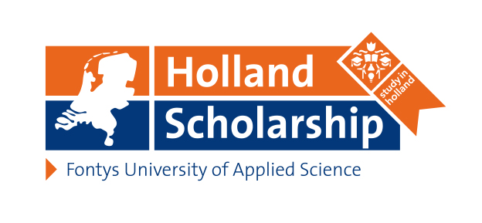
The Holland Scholarship is financed by the Dutch Ministry of Education, Culture and Science as well as 48 Dutch research universities and universities of applied sciences. Fontys is one of these Universities of Applied Sciences.
There are scholarships for international students from outside the EEA* who want to do their bachelor’s or master’s in Holland, but also for Fontys students who wish to go abroad, specifically outside Europe to study or do an internship.
Scholarship
For outgoing students this one time scholarship of € 1.250,00 is paid as a contribution of tuition costs.

General criteria
- You are a fulltime student at a Dutch University or University of Applied Sciences
- You go abroad for at least 3 months and 15 ECTS.
- Your go to a country outside Europe for a study or internship

Application
Application for a study or internship abroad is mandatory via Mobility Online.

The procedure for applying for the scholarship as well as selection and granting is exercised by each Fontys school.

Please contact the Coordinator Internationalisation of your School to apply for the Holland Scholarship and learn more about the selection procedure and application deadlines.

*The EEA consists of the EU, Liechtenstein, Iceland and Norway

